EWMA correlation: USDJPY and USDCHF
Method 06 / daily log returns / lambda = 0.94 / Alpari D1 full available history

Study setup
Logical pair: USDJPY , USDCHF
Broker symbols: USDJPY_i , USDCHF_i
Snapshot: 2026-11-03_majors_alpari_D1
Timeframe: D1
Matched return window: 1999-01-05 to 2026-11-02 (UTC bar dates)
Matched return count n: 7185
Dropped unfinished last bar dated 2026-11-03 UTC after a tick-volume check against the prior complete day.
Lambda: 0.94 (today weight 0.06)
Burn-in ignored in path summaries and chart: first 60 updates
Mean adjustment: each leg demeaned by its mean on the matched rows
Seeds: c_0 = v_x,0 = v_y,0 = 0
Complete matched rows (Excel): USDJPY-USDCHF_EWMA_D1.xlsx
Complete matched rows (HTML table): USDJPY-USDCHF_EWMA_D1_data.html

Method carried forward
EWMA correlation updates covariance and variances of mean-adjusted daily log returns of close, ln(close_t / close_t-1), with lambda = 0.94 (6% weight on today's product or square, 94% on yesterday's EWMA state). Quotes are not inverted. Each leg is demeaned by its mean on the matched rows; that mean uses the full sample, so the rho path is a full-sample description, not a live filter. Seeds start at zero. Path summaries and the chart ignore the first 60 updates so the zero seed has faded. The headline is rho on the last day. rho is symmetric under swap of the two symbols. A high |rho| does not prove cause, lead-lag, or a trading signal. Today's return sits inside today's rho, so the estimate can only inform a later decision. Same-sample Pearson r is a side check only.

Results
Latest EWMA rho: 0.337960
Post-burn-in path (n=7125): mean=0.471332, median=0.515335, min=-0.459612, max=0.883602, std=0.242244
Share of post-burn-in days with |rho| >= 0.4: 69.96%; |rho| >= 0.7: 15.82%
Same-sample Pearson r: 0.399461
Latest rho minus r: -0.061501

Conclusion
Over 7185 matched daily log-return rows for USDJPY and USDCHF (broker quote directions unchanged), latest EWMA rho with lambda=0.94 is 0.3380 (positive, weak recent linear link in this sample). After a 60-day burn-in, path mean is 0.4713, std is 0.2422, and the range is [-0.4596, 0.8836]. Same-sample Pearson r is 0.3995 (latest rho minus r = -0.0615). This does not establish cause, lead-lag, or a lasting trading rule.

Charts
Daily closes

Daily log returns
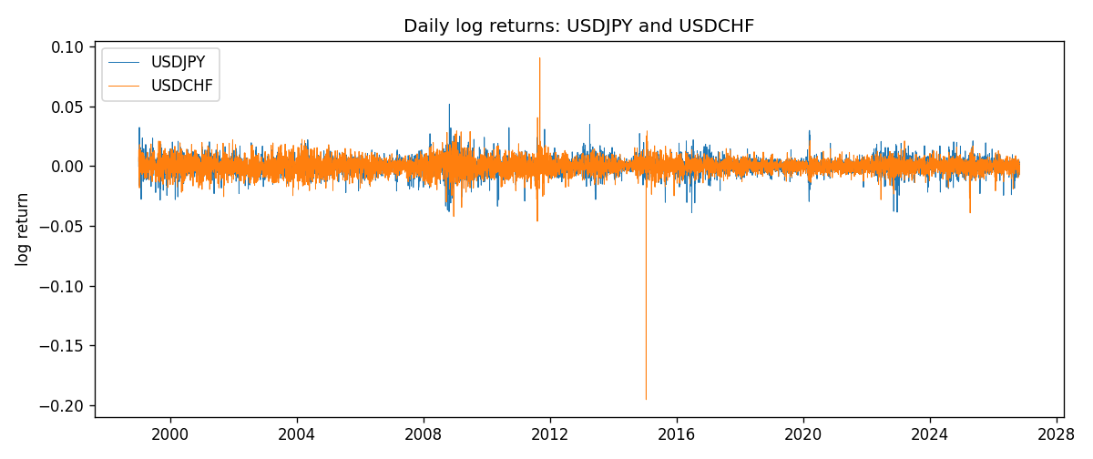
EWMA rho path with Pearson r reference
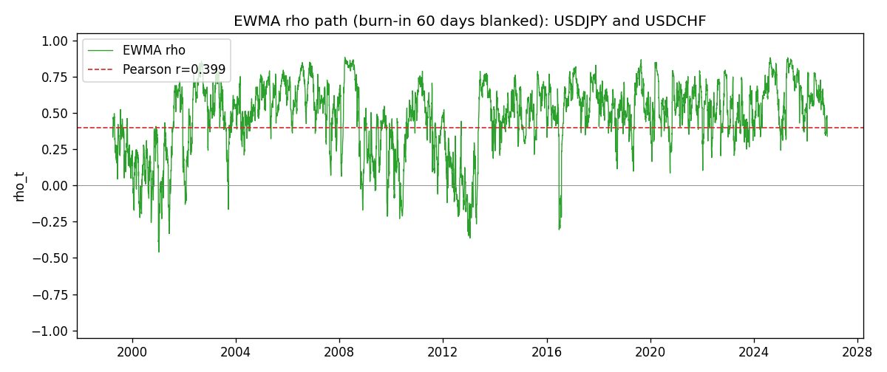

Data report
Every matched row that entered the EWMA recursion is stored in the sibling Excel workbook named USDJPY-USDCHF_EWMA_D1.xlsx. That file is the complete data archive for redrawing charts. Embedding all rows as a Word table is impractical at this length; the Word file holds the column list, column summaries, and the first and last 15 matched rows.
Columns: time, USDJPY_open, USDCHF_open, USDJPY_high, USDCHF_high, USDJPY_low, USDCHF_low, USDJPY_close, USDCHF_close, USDJPY_tick_volume, USDCHF_tick_volume, USDJPY_spread, USDCHF_spread, USDJPY_real_volume, USDCHF_real_volume, USDJPY_log_return, USDCHF_log_return, USDJPY_x_demeaned, USDCHF_y_demeaned, c_t, v_x, v_y, rho_t
Column summaries (matched calculation rows)
column | count | mean | std | min | 25% | 50% | 75% | max
USDJPY_open | 7185 | 113.80726 | 19.2236 | 75.693 | 104.38 | 110.984 | 120.69 | 163.824
USDCHF_open | 7185 | 1.0974395 | 0.25223318 | 0.72022 | 0.92053 | 0.98988 | 1.2375 | 1.8219
USDJPY_high | 7185 | 114.30433 | 19.285132 | 76.001 | 104.865 | 111.442 | 121.257 | 163.978
USDCHF_high | 7185 | 1.1027315 | 0.25397793 | 0.73305 | 0.92474 | 0.99353 | 1.2422 | 1.8313
USDJPY_low | 7185 | 113.28455 | 19.151449 | 75.402 | 103.87 | 110.53 | 120.17 | 163.628
USDCHF_low | 7185 | 1.0923205 | 0.25064913 | 0.08565 | 0.91719 | 0.98622 | 1.2315 | 1.8121
USDJPY_close | 7185 | 113.82023 | 19.238853 | 75.811 | 104.38 | 111.025 | 120.68 | 163.851
USDCHF_close | 7185 | 1.0974333 | 0.25214008 | 0.72025 | 0.92079 | 0.98995 | 1.2376 | 1.8217
USDJPY_tick_volume | 7185 | 106345.59 | 179437.4 | 149 | 9958 | 53202 | 92889 | 1803508
USDCHF_tick_volume | 7185 | 74334.331 | 113494.7 | 18 | 12809 | 40241 | 70443 | 858589
USDJPY_spread | 7185 | 20.263883 | 17.612444 | 0 | 6 | 11 | 30 | 50
USDCHF_spread | 7185 | 26.03215 | 24.694045 | 0 | 5 | 16 | 50 | 100
USDJPY_real_volume | 7185 | 3.4781051e+10 | 1.6093614e+11 | 0 | 0 | 0 | 0 | 3.8834203e+12
USDCHF_real_volume | 7185 | 2.3294091e+10 | 8.9133595e+10 | 0 | 0 | 0 | 0 | 1.9331921e+12
USDJPY_log_return | 7185 | 4.82e-05 | 0.00620617 | -0.03908203 | -0.00320044 | 0.00011473 | 0.00340924 | 0.05184024
USDCHF_log_return | 7185 | -6.962e-05 | 0.0065941 | -0.19545699 | -0.0033516 | 8.06e-05 | 0.00332472 | 0.09051364
USDJPY_x_demeaned | 7185 | 0 | 0.00620617 | -0.03913023 | -0.00324864 | 6.653e-05 | 0.00336105 | 0.05179204
USDCHF_y_demeaned | 7185 | 0 | 0.0065941 | -0.19538737 | -0.00328198 | 0.00015022 | 0.00339434 | 0.09058326
c_t | 7185 | 1.633e-05 | 1.519e-05 | -2.96e-05 | 7.32e-06 | 1.387e-05 | 2.143e-05 | 0.00015462
v_x | 7185 | 3.848e-05 | 3.193e-05 | 0 | 1.902e-05 | 3.088e-05 | 4.766e-05 | 0.00041229
v_y | 7185 | 4.344e-05 | 9.02e-05 | 9.7e-07 | 1.84e-05 | 2.967e-05 | 4.763e-05 | 0.00231226
rho_t | 7185 | 0.46897337 | 0.244399 | -1 | 0.34977642 | 0.51331248 | 0.64441248 | 0.95343242
First 15 matched rows (selected columns)
time | USDJPY_close | USDCHF_close | USDJPY_log_return | USDCHF_log_return | USDJPY_x_demeaned | USDCHF_y_demeaned | c_t | v_x | v_y | rho_t
1999-01-05 | 111.92 | 1.3724 | -0.00017868311 | 0.0039424743 | -0.00022687951 | 0.0040120941 | -5.4615717e-08 | 3.0884587e-09 | 9.6581396e-07 | -1
1999-01-06 | 112.77 | 1.3912 | 0.0075660159 | 0.013605652 | 0.0075178195 | 0.013675272 | 6.1171548e-06 | 3.3939597e-06 | 1.2128649e-05 | 0.95343242
1999-01-07 | 111.33 | 1.3782 | -0.012851583 | -0.0093883841 | -0.012899779 | -0.0093187643 | 1.2962725e-05 | 1.317458e-05 | 1.6611292e-05 | 0.87624636
1999-01-08 | 110.8 | 1.3935 | -0.0047719894 | 0.011040268 | -0.0048201858 | 0.011109888 | 8.9718584e-06 | 1.3778157e-05 | 2.3020391e-05 | 0.50376792
1999-01-11 | 109.02 | 1.4009 | -0.016195423 | 0.0052963193 | -0.016243619 | 0.0053659391 | 3.2038106e-06 | 2.8782777e-05 | 2.3366766e-05 | 0.12353818
1999-01-12 | 112.6 | 1.3872 | 0.032310364 | -0.0098275602 | 0.032262168 | -0.0097579403 | -1.5877156e-05 | 8.9506658e-05 | 2.7677804e-05 | -0.31899159
1999-01-13 | 113.52 | 1.3621 | 0.0081373171 | -0.018259701 | 0.0080891207 | -0.018190081 | -2.3753033e-05 | 8.8062291e-05 | 4.5869878e-05 | -0.373732
1999-01-14 | 113.52 | 1.3588 | 0 | -0.0024256692 | -4.8196405e-05 | -0.0023560493 | -2.2321037e-05 | 8.2778693e-05 | 4.3450743e-05 | -0.37218296
1999-01-15 | 114.15 | 1.3834 | 0.0055343401 | 0.01794228 | 0.0054861437 | 0.0180119 | -1.5052823e-05 | 7.9617838e-05 | 6.030941e-05 | -0.21723021
1999-01-18 | 114.16 | 1.379 | 8.7600193e-05 | -0.0031856384 | 3.9403788e-05 | -0.0031160185 | -1.4157021e-05 | 7.4840861e-05 | 5.727342e-05 | -0.21623496
1999-01-19 | 113.52 | 1.3789 | -0.0056219403 | -7.2518946e-05 | -0.0056701367 | -2.8990798e-06 | -1.3306613e-05 | 7.2279436e-05 | 5.3837015e-05 | -0.21331415
1999-01-20 | 112.91 | 1.3889 | -0.0053879917 | 0.0072259871 | -0.0054361881 | 0.0072956069 | -1.4887834e-05 | 6.9715798e-05 | 5.3800347e-05 | -0.24309351
1999-01-21 | 113.87 | 1.3836 | 0.0084664056 | -0.0038232689 | 0.0084182092 | -0.003753649 | -1.5890504e-05 | 6.9784825e-05 | 5.1417719e-05 | -0.26527771
1999-01-22 | 114.56 | 1.3834 | 0.0060412564 | -0.0001445609 | 0.00599306 | -7.4941031e-05 | -1.4964021e-05 | 6.7752742e-05 | 4.8332993e-05 | -0.26149478
1999-01-25 | 113.72 | 1.3868 | -0.0073594164 | 0.0024546976 | -0.0074076128 | 0.0025243175 | -1.518813e-05 | 6.6979941e-05 | 4.5815344e-05 | -0.27417411
Last 15 matched rows (selected columns)
time | USDJPY_close | USDCHF_close | USDJPY_log_return | USDCHF_log_return | USDJPY_x_demeaned | USDCHF_y_demeaned | c_t | v_x | v_y | rho_t
2026-10-13 | 158.305 | 0.83244 | -0.0018932826 | -0.0024955621 | -0.001941479 | -0.0024259422 | 5.9829284e-06 | 1.9770107e-05 | 1.3294241e-05 | 0.36904346
2026-10-14 | 158.317 | 0.83489 | 7.5800166e-05 | 0.0029388325 | 2.7603761e-05 | 0.0030084523 | 5.6289354e-06 | 1.8583947e-05 | 1.3039634e-05 | 0.36159681
2026-10-15 | 158.024 | 0.82676 | -0.0018524319 | -0.0097855323 | -0.0019006283 | -0.0097159124 | 6.3991795e-06 | 1.7685653e-05 | 1.7921193e-05 | 0.35944321
2026-10-16 | 157.964 | 0.82377 | -0.00037976126 | -0.0036230826 | -0.00042795767 | -0.0035534627 | 6.1064727e-06 | 1.6635503e-05 | 1.7603547e-05 | 0.35683904
2026-10-19 | 158.517 | 0.82677 | 0.0034946841 | 0.0036351779 | 0.0034464877 | 0.0037047978 | 6.5061967e-06 | 1.6350069e-05 | 1.7370866e-05 | 0.38606165
2026-10-20 | 158.16 | 0.8246 | -0.0022546642 | -0.0026281224 | -0.0023028606 | -0.0025585025 | 6.4693374e-06 | 1.5687255e-05 | 1.672137e-05 | 0.39943893
2026-10-21 | 158.108 | 0.82427 | -0.00032883504 | -0.00040027413 | -0.00037703145 | -0.00033065427 | 6.0886572e-06 | 1.4754549e-05 | 1.5724648e-05 | 0.39973124
2026-10-22 | 156.755 | 0.82032 | -0.0085942669 | -0.0048036381 | -0.0086424633 | -0.0047340182 | 8.1781525e-06 | 1.8350806e-05 | 1.6125825e-05 | 0.47540819
2026-10-23 | 156.81 | 0.82497 | 0.00035080446 | 0.005652514 | 0.00030260806 | 0.0057221339 | 7.7913572e-06 | 1.7255252e-05 | 1.7122844e-05 | 0.45327786
2026-10-26 | 157.458 | 0.82649 | 0.0041238746 | 0.0018407959 | 0.0040756782 | 0.0019104158 | 7.7910501e-06 | 1.7216606e-05 | 1.6314455e-05 | 0.46487473
2026-10-27 | 157.894 | 0.82865 | 0.0027651658 | 0.0026100526 | 0.0027169694 | 0.0026796725 | 7.7604224e-06 | 1.6626525e-05 | 1.5766426e-05 | 0.47931165
2026-10-28 | 157.743 | 0.82781 | -0.00095679538 | -0.0010142111 | -0.0010049918 | -0.00094459125 | 7.3517554e-06 | 1.5689534e-05 | 1.4873976e-05 | 0.48125194
2026-10-29 | 157.683 | 0.82379 | -0.00038043789 | -0.0048680164 | -0.00042863429 | -0.0047983965 | 7.0340556e-06 | 1.4759186e-05 | 1.5363014e-05 | 0.46712852
2026-10-30 | 157.516 | 0.82438 | -0.0010596481 | 0.00071594559 | -0.0011078445 | 0.00078556546 | 6.5597952e-06 | 1.3947274e-05 | 1.447826e-05 | 0.46162299
2026-11-02 | 157.933 | 0.81851 | 0.0026438521 | -0.0071459744 | 0.0025956556 | -0.0070763546 | 5.0641407e-06 | 1.3514683e-05 | 1.6614052e-05 | 0.3379598

